User Manual: Sequencer-Arpeggiator

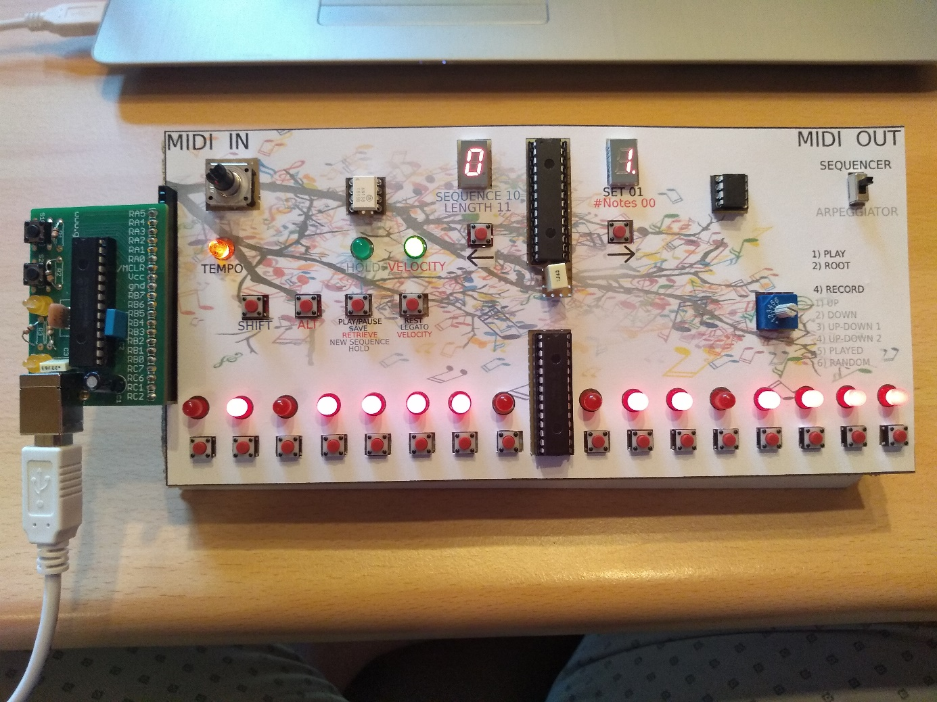

# Getting Started

To get started with this sequencer-arpeggiator, plug in the USB cable in any charger or computer port. This will not send any data, only deliver power to the device. Then, plug in a 5-pin MIDI cable from the MIDI-out of your recording instrument to the MIDI IN of this device, which is positioned on the left side. Then connect a second 5-pin MIDI cable from the MIDI OUT of this device (on the right side) to the MIDI IN of any MIDI instrument.

# Overview of the Device

# The Displays

The displays show different information based on the position of the mode switch and the SHIFT and ALT buttons. Some important names to remember:

* Sequence number: The sequencer has 32 memory slots to save sequences of up to 128 notes. These memory slots are indicated by different sequence numbers. On the next page you can see how these sequence numbers are displayed on
* Set: Since the device can only display 16 notes on its LEDs, longer sequences are divided into sets of 16 notes. Set 1 displays note 1 through 16, set 2 shows note 17 through 32 etc.
* Notes per beat: The amount of notes that will be played per beat.
* Sequence length: The amount of notes stored in the currently loaded sequence. This number is displayed in hexadecimal over the two displays.

In arpeggiator mode the left display is always off, the right display shows the number of notes in the current arpeggio (up to 31, more on that later).

In sequencer mode, different information is displayed based on the state of the SHIFT and ALT buttons. The overlay gives you some hints though!

|  |  |  |  |
| --- | --- | --- | --- |
| SHIFT | ALT | Left display | Right display |
| Off | Off | Sequence number | Set |
| Off | On | Sequence number | Notes per beat |
| On | Off | Sequence number | Set |
| On | On | Sequence length | Sequence length |

These On/Off states are also indicated on the overlay with 0 = off and 1 = on.

|  |  |
| --- | --- |
| Sequence number | Symbol |
| 0 | 0 |
| 1 | 1 |
| 2 | 2 |
| 3 | 3 |
| 4 | 4 |
| 5 | 5 |
| 6 | 6 |
| 7 | 7 |
| 8 | 8 |
| 9 | 9 |
| 10 | A |
| 11 | b |
| 12 | C |
| 13 | d |
| 14 | E |
| 15 | F |
| 16 | G |
| 17 | H |
| 18 | I |
| 19 | J |
| 20 | L |
| 21 | n |
| 22 | o |
| 23 | P |
| 24 | Q |
| 25 | r |
| 26 | t |
| 27 | U |
| 28 | y |
| 29 | c |
| 30 | h |
| 31 | i |

The sequence number is displayed on one display which can show these 32 different characters. Since there are only 10 single digit numbers I continued with the alphabet. Here is a list of the sequence.

After that I used lowercase letters for which both upper and lowercase letters could be represented on the display.

# The Arpeggiator

Let’s talk about the arpeggiator!

## The Basics

This thing has a fancy name so it must be cool right? Oh let me tell you!

In this mode, all notes that are being played (held down) on the MIDI-instrument will be put in a predefined sequence. This sequence will then be played on repeat. Some sequences play the same note twice. The right display will show you how many notes are in the arpeggio-sequence. These sequences can be up to 128 notes long, but I do not see any practical way of holding down that many notes, believe me, I tried.

An important thing to know: One full arpeggio will always be played per beat. This means that the more notes you add to the arpeggio, the faster they will be played!

You can change the tempo by turning the tempo knob.

To use the arpeggiator, make sure that the mode switch is set in the down position, indicated with ‘ARPEGGIATOR’ on the overlay. Arpeggiator-specific functions are indicated in grey on the overlay.

## Multiple Arpeggio Options

The key of this mode are the different possible arpeggiator sequences which can be changed with the function switch. I will make things clearer with an example.

|  |  |  |
| --- | --- | --- |
|  | Name | Sequence |
| 1 | UP | C-E-G-C+ |
| 2 | DOWN | C+-G-E-C |
| 3 | UP-DOWN 1 | C-E-G-C+-G-E-C |
| 4 | UP-DOWN 2 | C-E-G-C+-C+-G-E-C |
| 5 | PLAYED | Order you played in |
| 6 | RANDOM | Random order |

Imagine playing the following C major chord on your MIDI-instrument: C-E-G-C+ where the second C (C+) is an octave higher than the first. The different arpeggiator modes will then play the following sequences on repeat:

The first four sequence-options should be quite easy to understand when playing around with it. The last two might be a bit different.

In played mode the order in which you play the notes will be preserved. This can come in handy when you want more complex arpeggios.

In random mode, the order in which the notes will be played will be decided randomly every time.

## Extra Options

The arpeggiator has a HOLD mode which can be toggled by pressing the function 1 button, after which the HOLD LED will turn on. When this mode is active, the arpeggios will keep repeating even if you are no longer holding down notes on your MIDI-instrument. If you have released all notes and you play new ones, the previously held arpeggio will stop playing and the new one will take over! This comes in very handy when you want to switch between different chords.

By default all arpeggio notes will be played with the same standard velocity (i.e. ‘loudness’). You can make more complex sounding arpeggios by engaging the Velocity mode. This mode will play the notes with the same velocity that you played them on your instrument. In this way you can play very interesting things with the arpeggiator, but you have to be more careful with the way you play the notes. Engage this mode by pressing ALT + function 2 button as indicated with VELOCITY.

# The Sequencer

The sequencer is a bit more complex, but a smart person like you will get the hang of it in no time!

## The Basics

With the sequencer you can program certain melodies, save them in one of the 32 memory slots and retrieve them later to play them on repeat! This could be used to loop certain melodies or basslines while you play another instrument or sing along, the possibilities are endless! Well, not really endless since sequences can only be 128 notes long, sorry!

To use the sequencer, make sure that the mode switch is set in the up position, indicated with ‘SEQUENCER’ on the overlay. Sequencer-specific functions are indicated in black on the overlay.

Sequences are saved in sets of 16 notes so they can be displayed on the 16 LEDs at the bottom of the machine. When recording or playing, the set will automatically be changed when needed. To fix a recording mistake you might have to navigate through these sets. The set number is displayed by default on the right display. Check the ‘Navigating in a sequence and fixing mistakes’ section on the next page.

## Recording a Sequence

The first thing you will likely want to do is program the melody of your favorite 10 hour-looping internet video. I will walk you through it!

If this device has been used before, you might want to check if a certain sequence number is already in use or not. Check the ‘Retrieving a sequence’ paragraph on the next page for more information.

You can only record sequences when the function switch is in the fourth position. You can play sequences in any position, but I would suggest you switch to a different position to prevent accidental recordings.

### Notes Per Beat

When you are certain about the melody and the rhythm of the song, determine what the fastest rhythm is you will need. This is important! Slow basslines might only need one note per beat, but in other situations you might want more flexibility. Setting the notes per beat to uncommon numbers like 3 for triplets or even 5 or 7, can give you very interesting patterns, but only one setting is possible for a given sequence.

Set the correct number notes per beat by pressing ALT + left or right button. The maximum number of notes per beat is limited to 32. While ALT is held down, the current amount of notes per beat is displayed on the right display.

### Recording a Melody

After setting the correct number of notes per beat, we are ready to record the melody! The blinking LED shows in what position a new note will be recorded. Every note you play will be saved with a length equal to the fastest possible rhythm based on the notes per beat setting. You can record longer notes by adding legatos (SHIFT + function 2) and you can enter rests (function 2) as well.

Let’s say you kept the default setting of 4 notes per beat and your song is in the common 4/4 time signature. Every note you play will then be recorded as a 16th note and 16 notes will complete a full measure. If you want to record 8th notes, record the note as a 16th in the first position and add a legato in the next slot by pressing SHIFT+ function 2, indicated with LEGATO on the overlay. If you want to add even longer notes, just insert more legatos. Every legato extends the note with one minimum note length.

Rests can be inserted by simply pressing the function 2 button as indicated with REST on the overlay.

When you think you have entered your melody correctly, or you want to check if you are heading in the right direction you can play the sequence by pressing the function 1 button as indicated by PLAY/PAUSE on the overlay. To be safe, I suggest you set the function switch to a different position to prevent accidental recordings.

Remember to navigate to the correct position if you want to rerecord certain notes or extend the sequence. Navigation is explained in the next paragraph.

### Navigating in a Sequence and Fixing Mistakes

If you have made a mistake, pause the sequence and navigate to the notes that you want to change. Changing sets can be done by simply pressing the left and right arrows. The current set number is shown on the right display. Changing the active note (the one that is blinking and will be recorded next) can easily be done by pressing the button below the note you want to change in the currently displayed set. You can always play the sequence again from a certain point by moving the active note back (by pressing the button below it when the sequence is not playing) and pressing the play/pause button.

The velocity with which you record the notes will be saved automatically, but just like with the arpeggiator you can choose to switch between default velocity and recorded velocity. This can be done by pressing ALT + Function 2 as indicated with ‘VELOCITY’ on the overlay.

It might happen that you accidentally record more notes than you would like. In that case you can shorten the sequence by pressing SHIFT + ALT + left arrow. Unfortunately, you cannot move recorded notes by removing a note in the middle so beware of recording too many notes in the middle of your sequence, otherwise you will have to rerecord everything after the mistake.

### Saving Sequences

Once you are happy with the recorded sequence, you can save it on permanent memory. Navigate to a sequence number where you would like to save it by pressing SHIFT + left or right arrow. The sequence number is displayed on the left display. Saving can then be done by pressing SHIFT + function 1, as indicated with SAVE on the overlay. There is currently no way to check whether or not a certain sequence number is free without retrieving the sequence (which will overwrite your current sequence). I would suggest you check this before recording a sequence. Once you saved your sequence, you can switch of the power of your device without losing it.

### Retrieving Sequences

If you want to retrieve a previously recorded sequence or you want to check if a sequence number can be used for your next creation, navigate to the correct sequence number by pressing SHIFT + left or right arrow. Then you can retrieve the sequence by pressing ALT + function 1, as indicated by RETRIEVE on the overlay.

BEWARE: retrieving a sequence overwrites any sequence that is currently loaded. This might not be a problem if you have it stored permanently (see the ‘Saving sequences’ paragraph), but if you just recorded a new masterpiece and retrieve a different sequence before storing the newly recorded one, you are going to have a bad time! This also applies to switching between the sequencer and arpeggiator modes.

### New Sequence

You can always clear any currently active sequence by pressing SHIFT + ALT + function 1. This gives you a blank slate to start working again.

## Playing a Sequence

Once you have a sequence recorded, you can play it by pressing the function 1 button, indicated with PLAY/PAUSE on the overlay. You can change the tempo by turning the tempo knob.

Additionally, you can introduce some variation in the sequence by muting notes. This can only be done while the sequence is playing. Muting a note is done by pressing one of the 16 buttons below the note LEDs. Unmuting is done by pressing it again. You cannot mute/unmute rests, and if you mute legatos a note might not be turned off when you would expect. When you mute the note before a legato, you will get a rest as long as the note would have sounded. These things do not break anything, but it might give some unexpected results.

## Playing in Root Mode

There is one special mode that can be entered by setting the function switch to the second position. This is the ROOT setting as indicated on the overlay.

Recorded sequences can then be replayed in different scales and octaves. When you are in this mode, playing a note on your MIDI-instrument will make that note the first note of the sequence. All notes will be shifted up or down depending on the note you just played and what the original first note of the sequence was. If your original sequence starts with C4, pressing C3 will shift everything an octave down. Pressing a note different than C will transpose the sequence to a different scale!